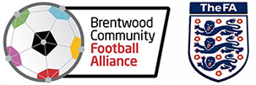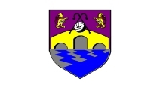

Brentwood Community Football Alliance (BCFA) – ex Chelmsford Youth Football League (CYFL) Development Fund (2023/2024)
Development Fund purpose: -
The BCFA CYFL Funds sub-committee would like to ensure any remaining funds from the CYFL are available to member clubs as set out below. There will be the opportunity for clubs to apply for grants, with the aim of helping clubs fulfil the FA requirements for training and development.

- Payment of BCFA Member fees for season 23/24 for ex CYFL teams that fully completed season 22-23, (any new /other teams will be responsible to make they own arrangement for Payments to BCFA)
- Grant for clubs towards the cost for Introduction to coaching Football courses for their coaches.
- Grant for clubs towards the FA Training costs for a Child Welfare Officer also Safeguarding Children
- Grant for clubs towards the costs for referee training.

Eligibility for access to the BCFA Development Fund is as follows: -
- All clubs must have at least one team in the BCFA to be eligible for any Grant
- Clubs must make application for grants
- Courses must be undertaken in the season they are requested
- Applications will be constantly reviewed, if funds are oversubscribed then preference will be given to smaller clubs.
- A restriction of a maximum of 2 Grants per club per Season. Unless otherwise advised

In addition, if there is very high demand for grants, the BCFA CYFL Funds sub-committee will look to allocate funds based on the size of each club.

50% of cost for small clubs up 2 teams in the club regardless of league

30% of cost for small clubs up 6 teams in the club regardless of league

20% of cost for small clubs up 8 teams in the club regardless of league

10% of cost for any larger clubs
Payment will be made on evidence the FA course having been booked and no further application will be viewed from the Club until the said course has been completed

